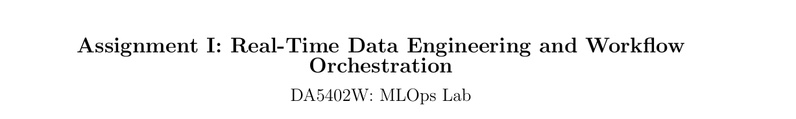
Details :
Roll Number : DA25M502
Name : Amardeep Kumar
Software Requirements
Spark : 3.5.6
Jdk 17
Apache Kakfka : 7.6.0
Docker

Part B
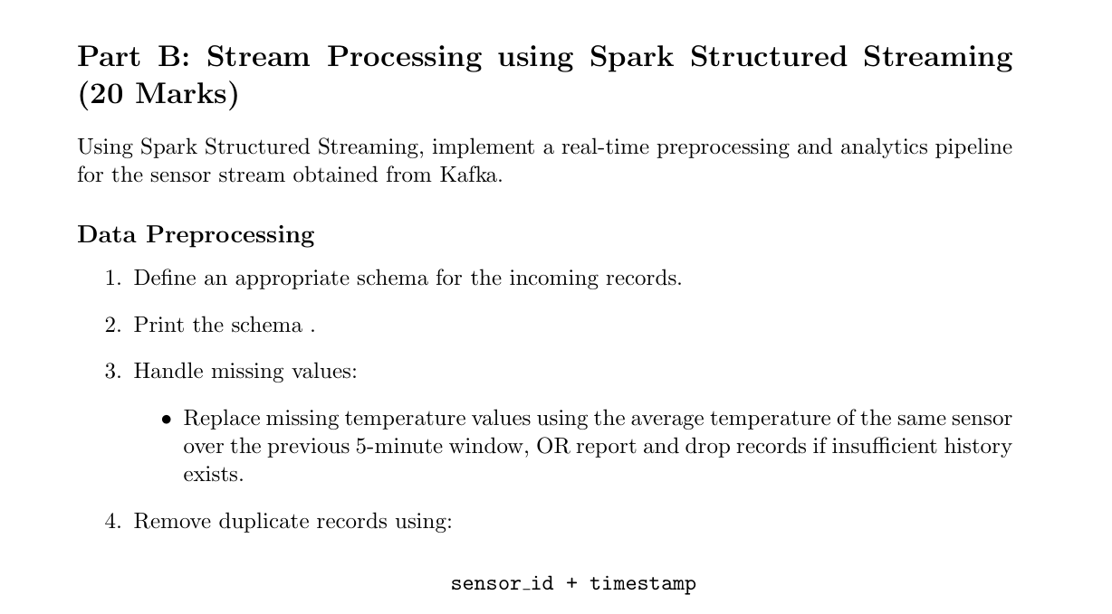
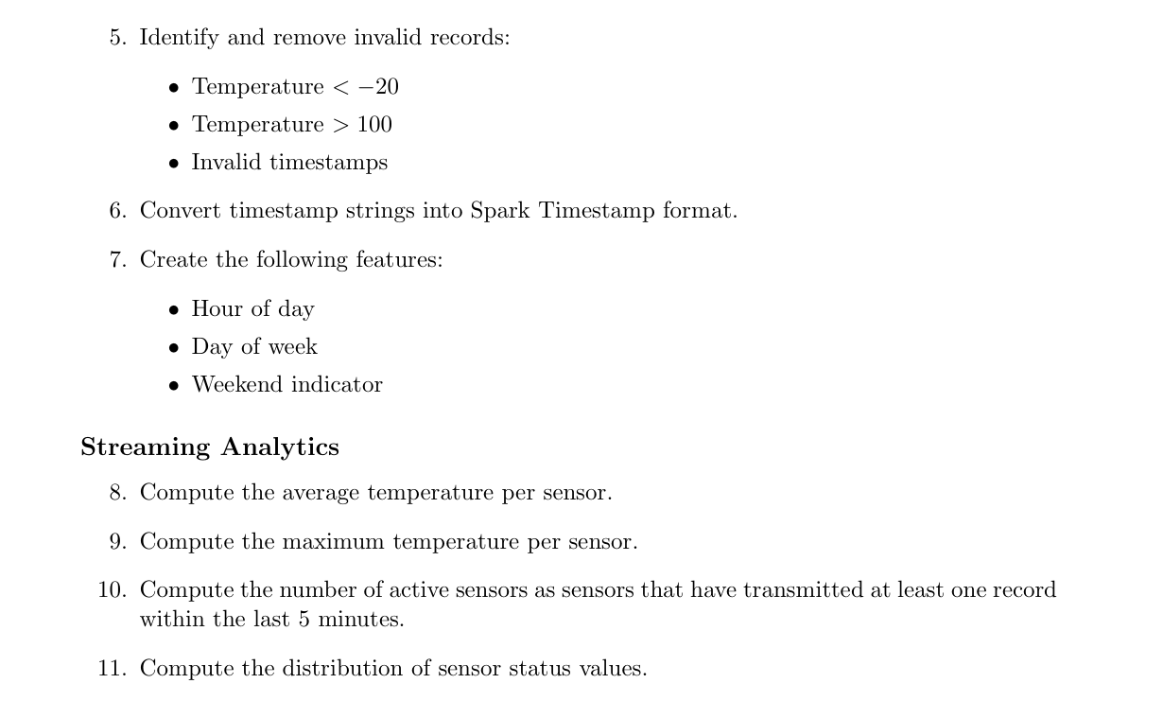
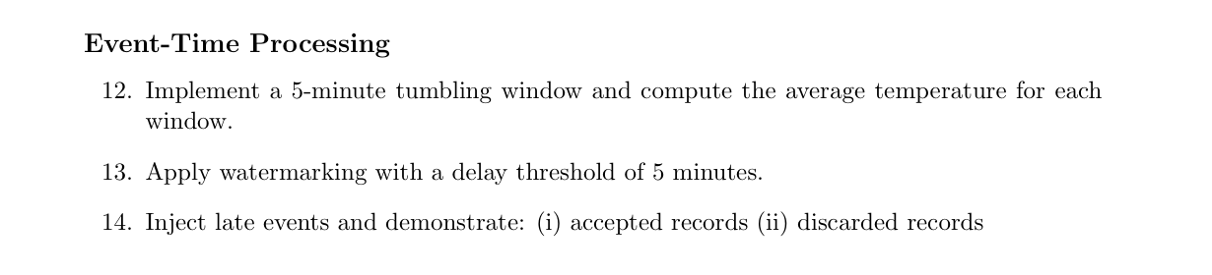
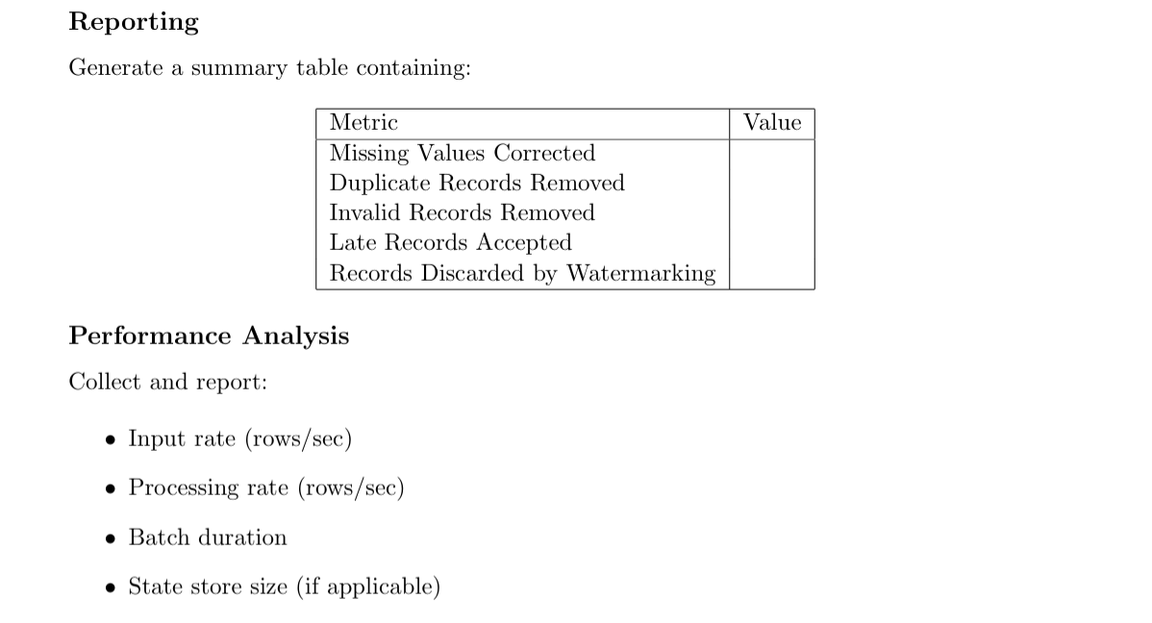
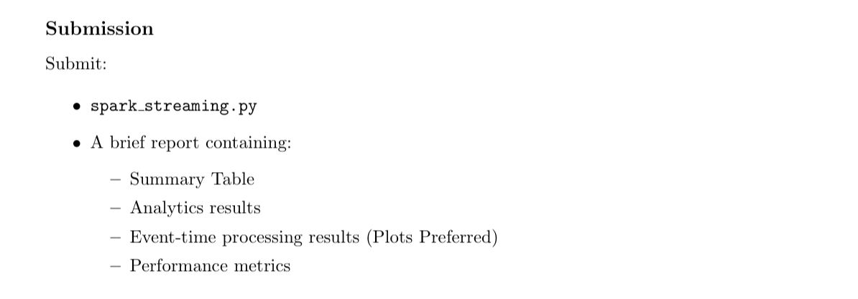

Pre-requisite
From part A
# Create Kafka topic + # Configure the topic
docker exec -it docker-kafka-1 bash
kafka-topics --bootstrap-server localhost:9092 --create --topic sensor_da25m502 --partitions 3 --replication-factor 1
- confirm the configuration
kafka-topics --bootstrap-server localhost:9092 --describe --topic sensor_da25m502
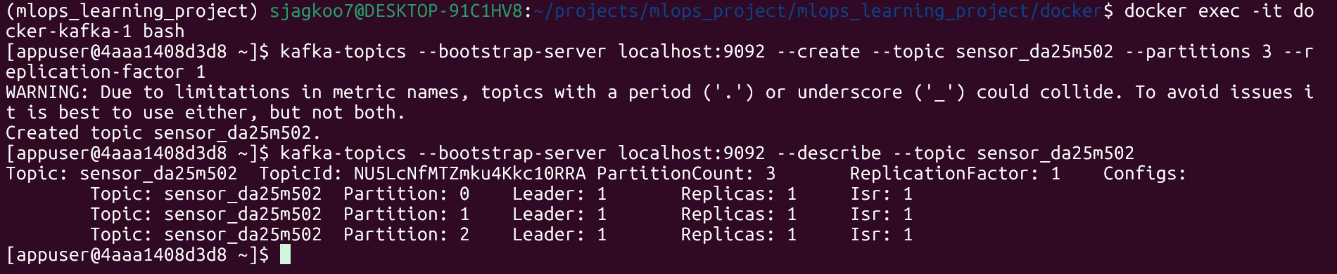

Spark Run – Full Run report
First Terminal: python spark_streaming.py
Second Terminal: python producer.py --topic sensor_da25m502 --records 5000 --rate 50

Data Processing

Step 1: Schema for the incoming records + Step 2: Print the schema
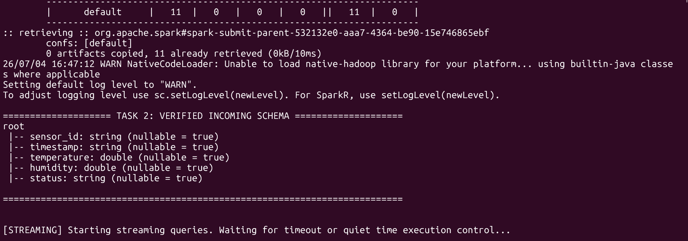
As we can see that it has displayed the schema i.e. sensor_id , timestamp , temperature , humidity and status.

Step 3 : Handle missing + Step 4 : Remove duplicate + Step 5: Identify and remove invalid records + 6. Spark Timestamp format + 7. Create features
Coded in spark_streaming.py.

Streaming Analytics

Step 8 . Average temperature per sensor + Step 9. Maximum temperature per sensor + 10. Number of active sensors + 11. Distribution of sensor status
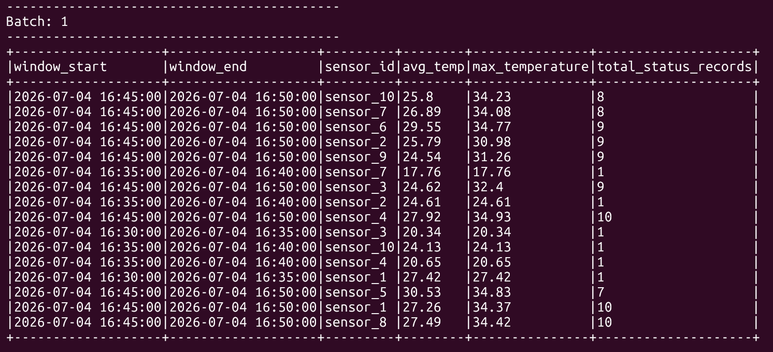
As screenshot shows that each batch has calculated the window of 5 min , avg temp , max temp , active sensor and record status (i.e. distribution)

Event-Time Processing

Step 12 . 5-minute tumbling window + Step 13 . Watermarking + Step 14. Inject late events
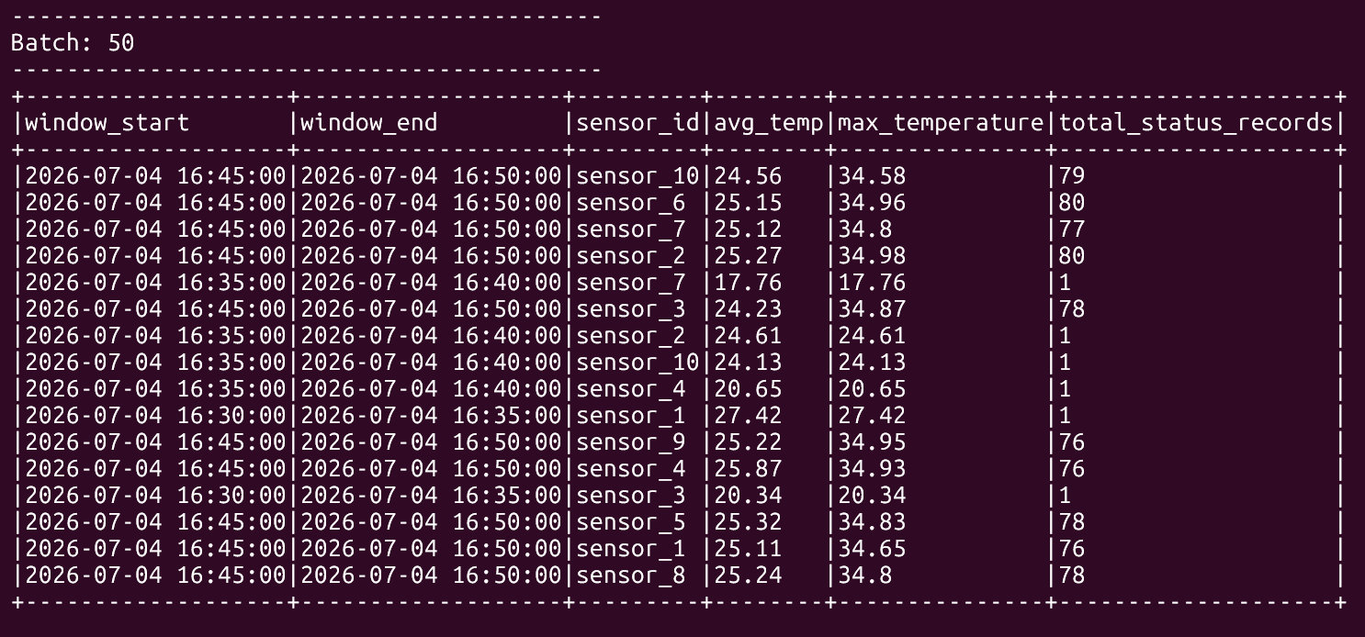

Look at the windows from 16:45:00 to 16:50:00 (e.g., sensor_10). They have around 79 records each. This represents your normal stream distribution.
Look at the windows like 16:35:00 to 16:40:00 for sensor_7 which has a total_status_records of exactly 1. These are the late-arriving records from producer back-dated by 5 to 10 minutes! This explains watermark strategy caught them and correctly assigned them to their historical windows.
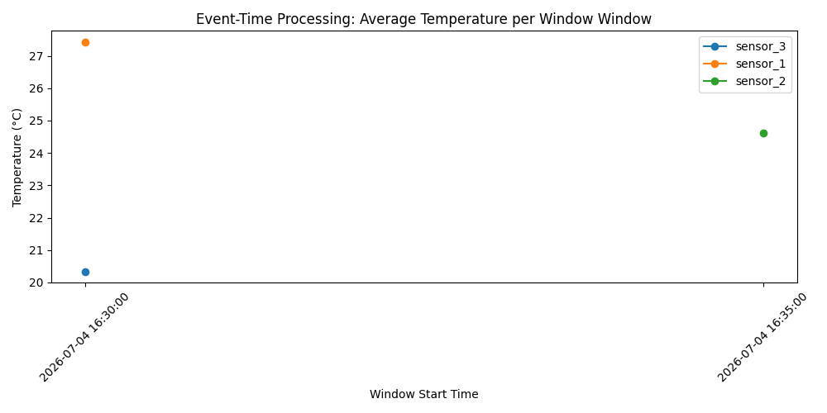

Reporting

Summary Table
Metric | Value
Missing Values Corrected | 0
Duplicate Records Removed | 3678
Invalid Records Removed | 4
Late Records Accepted | 48
Records Discarded by Watermarking | 118

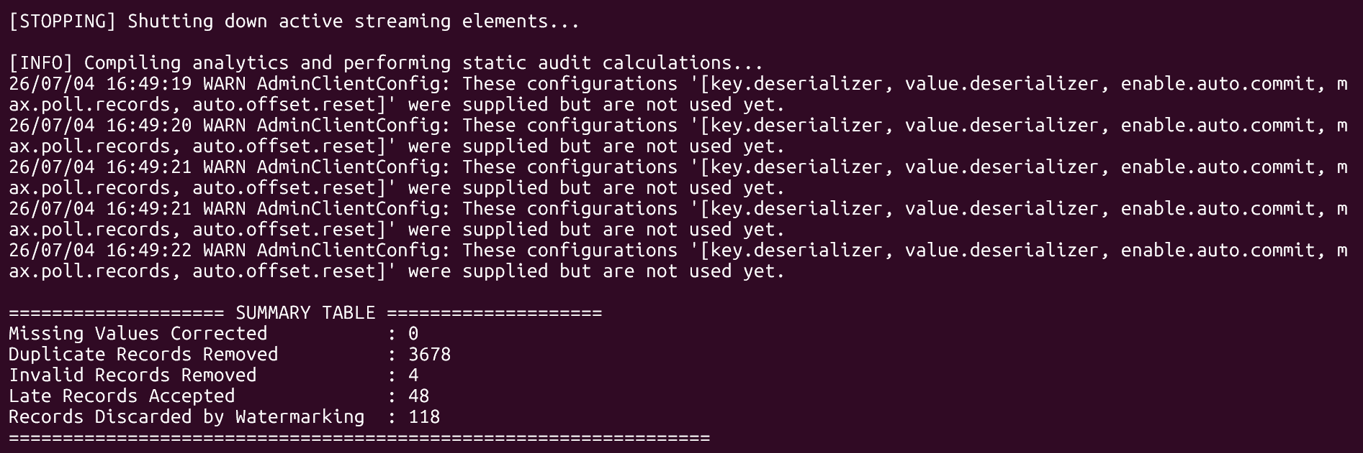

Performance Analysis

Metrics
Input rate (rows/sec) + Processing rate (rows/sec) + Batch duration + State store size (if applicable)
This insertion same batch twice because I am running:
query_console (which prints the complete table to your terminal screen)
query_csv (which continuously appends rows into your reporting folder).
{
"batch_id": 2,
"input_rate_rps": 46.03,
"processing_rate_rps": 50.65,
"batch_duration_ms": 1994
},
{
"batch_id": 3,
"input_rate_rps": 45.85,
"processing_rate_rps": 49.5,
"batch_duration_ms": 1997
},

